The essence of law: algorithm vs morality
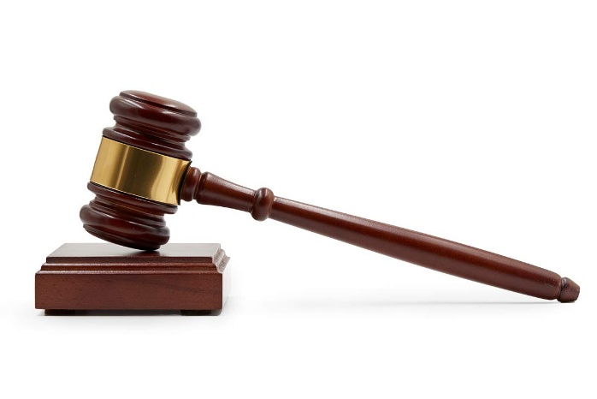

(image source : Amazon)
Recently, there are many AI and algorithms in diverse field in our society. Even, AI is utilized in law field. They are assisting lawyers and judges with many ways. For example, they assist analyzing written judgement, case law search etc. Their roles will be more important developing AI technologies. This situation leads to controversial issues about whether we should replace judge to AI. Also, these issues lead to the controversial discussion about essence of law. We can find two perspectives about essence of law : algorithm vs morality. As this issue can be connected to your real judgement, I think you are interested in this topic. Let’s discuss more specific questions about this topic.
There are two questions before we talk about this topic specifically. First one is whether bad law is law. I also give you some articles about that. In this article, there is a best example of this case. Second one is definition of natural law. many people don’t know well about laws. So, I recommend you to watch this Youtube video first for understanding what nature law is. If you want to discuss with other people, use comment function of this blog! From now on, I give you two theories related to main topic.
## Legal positivism
First of all, I recommend you to watch this Youtube video for understanding what legal positivism is. This theory is a representative theory about considering law as algorithm. It analyzes law logically on the premise of the completeness of the law. Also, it separates law and morality completely and prioritize positive law than natural law. Positive law means only passed law by legislature. In contrast, natural law means the unchangeable laws based on human reason and universal reason. It applies in every time and every space. Also, natural law theorists argue that this law is not made by human and it is just originally inherent in space. In legal positivism, it denies existence of natural law. It just prioritize procedure. The best issue related to legal positivism is whether bad law is law. Legal positivism theorists argues that bad law is also law. But, about this, there are many controversial issues. Do you remember the articles I give you before? In this article, there are two examples. First one is a famous case where legal positivism was not applied - Nuremberg trials. After World War ∥, Trials were held for punishing Nazi war criminals. But, the significant legal dilemma arose. They asserted that they just follow their German law and it is impossible to punish themselves after changing the law due to the principle of non-retroactivity. Their assertion is based on legal positivism. But, panel of judges didn’t accept their assertion. Panel of judges adjudicated that natural law is more higher law than positive law. This example is one of the best examples not to apply legal positivism in court. Next, second one is a suggested example in the article about applying legal positivism at Sweden. It is introducing the Sweden minister’s case. She was arrested for drunk-driving in the southern city of Malmo. She could use her power for resolving this situation, but ultimately, she resigned her ministerial position. This example is a representative example for applying legal positivism correctly. Legal positivism considers law as procedures and guards against subjectivity of law. Due to the traits of legal positivism, the punishment can be applied for her excluding subjectivity. Until now, we talked about two opposite examples about legal positivism. When summarizing the content so far, the key points of legal positivism are excluding subjectivity, and controversial issues about morality and natural law.

## Natural law theory
Prior to introducing this theory, I also recommend you to read this article. If you read this article with the Youtube video I give you before, you can understand this theory more easier. As I already explain natural law in previous paragraph, You can easily understand this concept. This theory is representative theory about considering law as morality. It analyzes law with value-oriented approach on the premise of moral justification. Also, natural law theorists argue that natural law should be prioritized over positive law and it can reflect morality in law. In other words, natural law theory is opposite theory from legal positivism. It can resolve the controversial issue of legal positivism : whether bad law is law. But, it also exists another controversial issue : subjectivity. Many law theorists assert the reason why nation prohibits private sanction is subjectivity. Following their assertion, if private sanction is allowed in nation, people would do private sanction with their each justice and it would cause social collapse. Thus, They assert that law is necessary for doing objective role. But, if morality is added in law, It is hard to avoid negative opinion to them about how law distinguishes itself from private sanction. It is a controversial issue. When summarizing the content so far, the key points of natural law theory are including morality in law and controversial issues about subjectivity.

## Conclusion
Until now, we have explored two theories related to this topic. What do you think about these two theories? Which theory is more persuasive to you? I hope that this blog can be an opportunity to think about and discuss this topic. Lastly, I want to ask you this question. Is perfect legal positivism possible in reality? Thank you.

References
1. Devprakash, C. (2021, May 7). Relevance of Legal Positivism in Modern Society. Manupatra.
https://articles.manupatra.com/article-details/Relevance-of-Legal-Positivism-in-Modern-Society
2. Iacoboni, S. J. (2024, April 25). A Closer Look at Natural Law. Science and Culture Today.
https://scienceandculture.com/2024/04/a-closer-look-at-natural-law/

3. Kaplan, J. (2023, May 5). Legal Positivism – the dominant theory in jurisprudence(Video).Youtube
https://www.youtube.com/watch?v=hWsw2Wai9BI

4. The Fraser Institute. (2022, January 8). Essential Natural Law : What is Natural Law?(Video).Youtube.
https://www.youtube.com/watch?v=VmeMmFeEbSA

